MACHINE LEARNING MODEL EXPLORATION
Using Google Teachable Machine
Name: Vijay Pradhap
Course: MCA
Subject: Machine Learning / Practical
Platform: Google Teachable Machine

1. Introduction
Machine Learning is a branch of Artificial Intelligence that enables computers to learn patterns from data and make predictions. Image classification is a common Machine Learning application in which a model learns to identify different categories from images.
In this experiment, Google Teachable Machine is used to create a simple traffic sign recognition model. The model is trained using three traffic sign categories: STOP, LEFT TURN, and RIGHT TURN.

2. Objective
The objectives of this experiment are:
- To explore a beginner-friendly Machine Learning platform.
- To understand the basic concept of image classification.
- To create training examples for different traffic signs.
- To train an image classification model.
- To test the model using new traffic sign inputs.
- To observe the prediction results.
- To understand a simple Computer Vision application.

3. Platform Used
Google Teachable Machine
Teachable Machine is a browser-based platform that allows users to create simple Machine Learning models using images, sounds, and poses without requiring advanced programming.
Model Configuration
Parameter | Details
Platform | Google Teachable Machine
Model | Image Classification
Input | Images / Webcam
Number of Classes | 3
Class 1 | STOP
Class 2 | LEFT TURN
Class 3 | RIGHT TURN
4. Training Dataset
Three traffic-sign categories were selected for the experiment.
Class | Sign
STOP | Stop traffic sign
LEFT TURN | Left-turn traffic sign
RIGHT TURN | Right-turn traffic sign
Multiple examples were collected for each category with variations in position, distance, angle, and background.
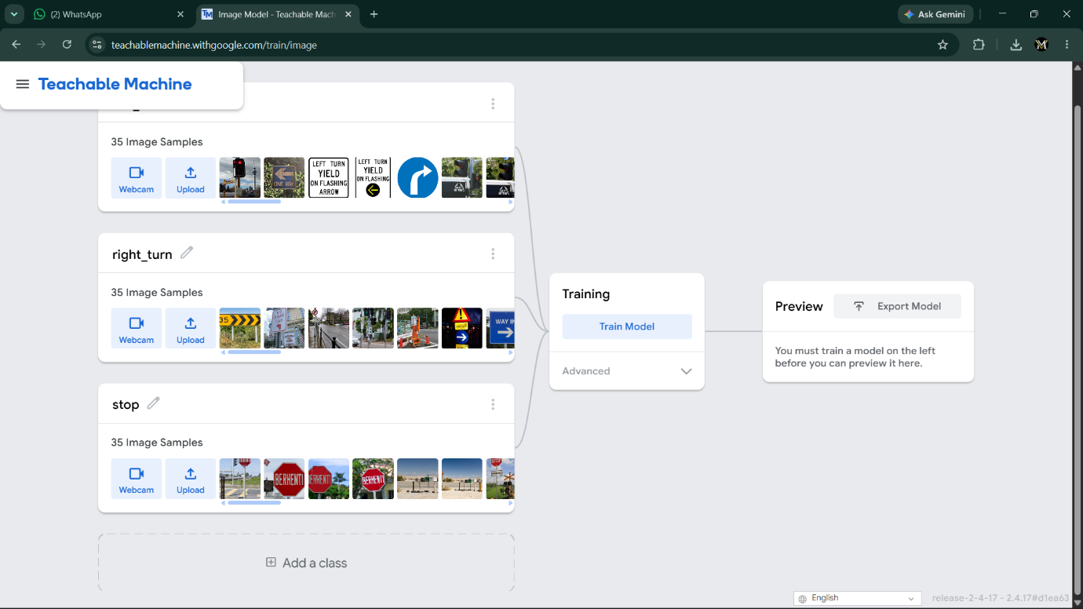Figure 1: Training examples for the three traffic sign classes

5. Model Training
After collecting the training examples, the Train Model option was selected.
The Machine Learning system processed the examples and learned visual patterns associated with each traffic-sign class.
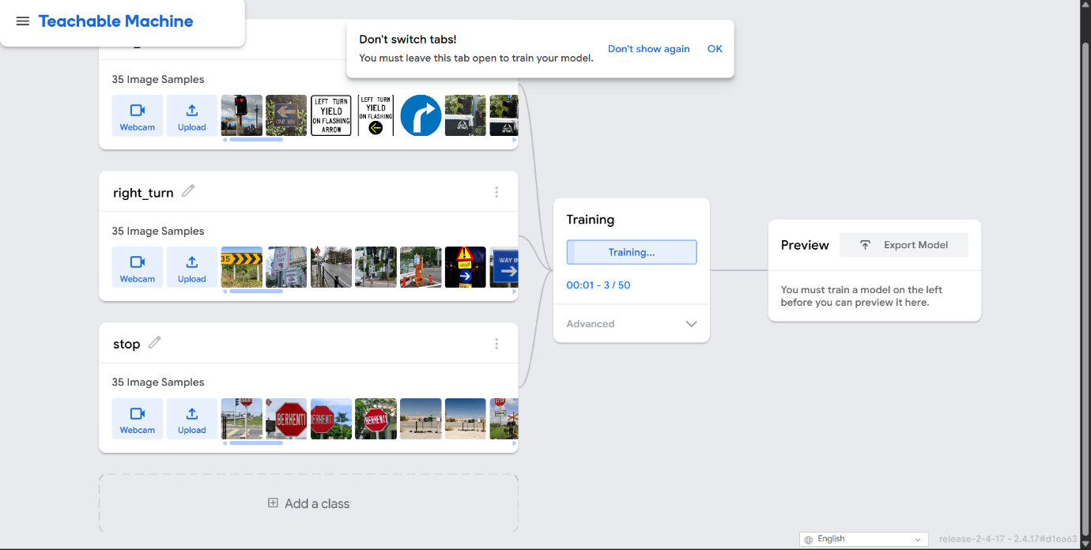
Figure 2: Training the traffic sign classification model

Training Flow
Traffic Sign Images
↓
Class Labels
↓
Model Training
↓
Trained Classifier

PAGE 6 — MODEL TESTING
6. Testing the Model
After training, new traffic-sign inputs were provided through the webcam.
Test 1 — STOP
Input: New STOP sign
Expected category: STOP
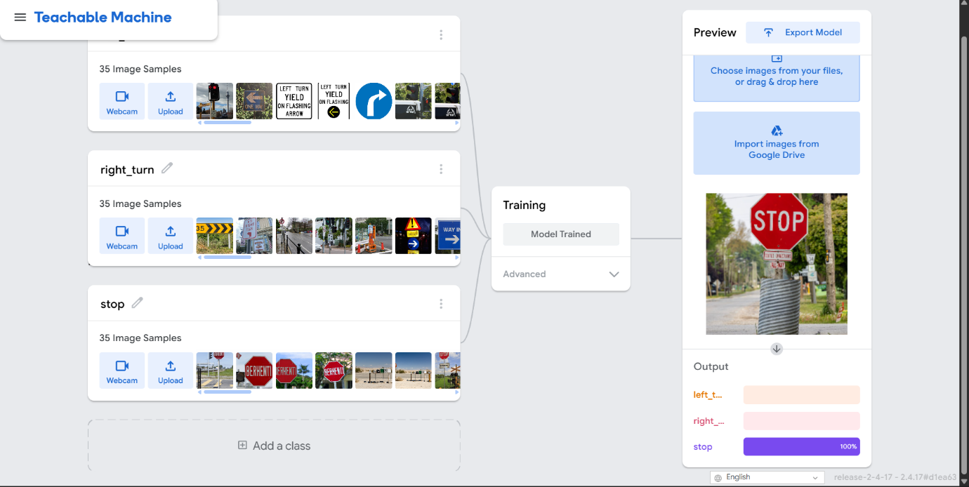
Figure 3: STOP sign classification

Test 2 — LEFT TURN
Input: New LEFT TURN sign
Expected category: LEFT TURN
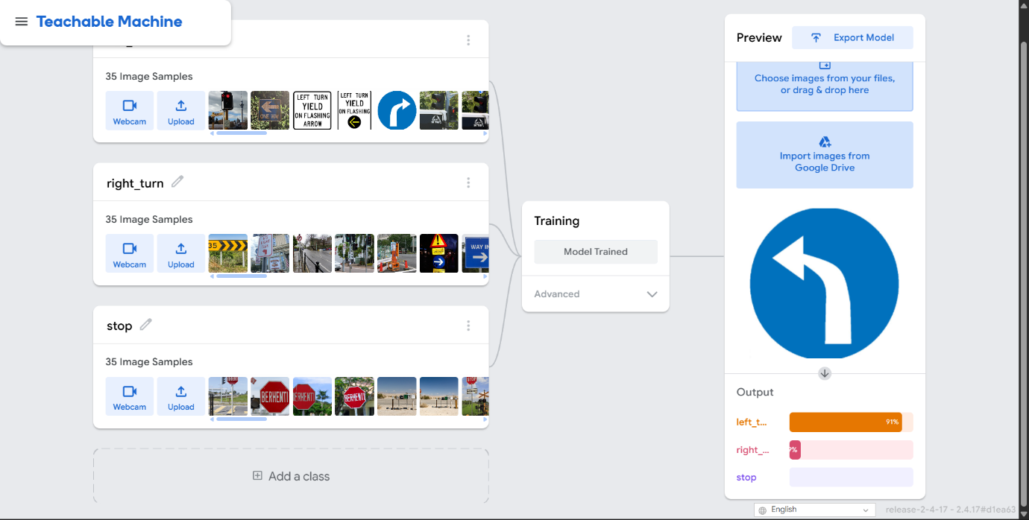
Figure 4: LEFT TURN sign classification

Test 3 — RIGHT TURN
Input: New RIGHT TURN sign
Expected category: RIGHT TURN
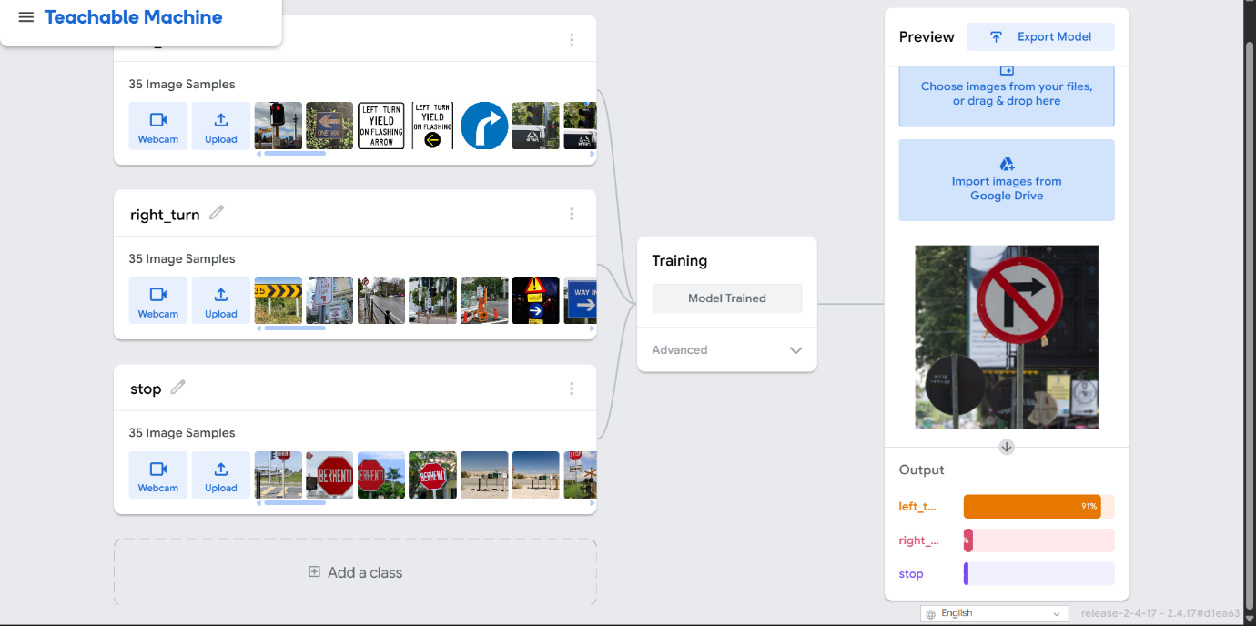
Figure 5: RIGHT TURN sign classification

7. Observation
The experiment demonstrated that a Machine Learning model can learn visual patterns from labelled examples and use those patterns to classify new inputs.
The prediction can be affected by factors such as:
- Lighting
- Camera quality
- Sign orientation
- Distance from the camera
- Background
- Image quality
- Number and variety of training examples
The experiment also showed that a basic classifier should not automatically be interpreted as a complete traffic-sign recognition system. It was trained only for the three categories included in the experiment.
8. Real-World Application
Traffic-sign recognition is an example of Computer Vision that can be used as part of larger intelligent transportation systems.
A simplified concept is:
Camera
↓
Road Image
↓
Computer Vision
↓
Traffic Sign Detection
↓
Sign Classification
↓
STOP / LEFT / RIGHT
↓
Information for Driver / Vehicle System
Possible applications include:
- Driver-assistance systems
- Intelligent transportation systems
- Road-safety applications
- Autonomous-vehicle research
- Traffic monitoring
Note: This classroom model is only a basic demonstration and should not be treated as a safety-critical traffic-sign system.
9. Conclusion
This experiment provided practical experience with Machine Learning using Google Teachable Machine. A simple image classification model was created to recognize three traffic-sign categories: STOP, LEFT TURN, and RIGHT TURN.
The experiment demonstrated the basic workflow of collecting training data, assigning classes, training a model, providing new inputs, and observing predictions. It also helped illustrate how factors such as training data and image conditions can affect Machine Learning results.

